EVENT SITE MEASUREMENT
TRIPLE JUMP

Rule Requirement
Runway | Length | Men | m
 |  | Women | m
 | Width |  | m
 | It is marked by white lines 0.05m in width |  | ☐ YES ☐ NO
Inclination | The maximum lateral inclination of the runway is less than 1:100 |  | ☐ YES ☐ NO
 | In the last 40m of the runway, the overall downward inclination in the running direction is less than 1:1000 |  | ☐ YES ☐ NO
Take-off board | It is in accordance with the rule |  | ☐ YES ☐ NO
 | Distance between the take-off line and the far end of the landing area | Men | m
 |  | Women | m
 | Distance between the take-off line and the nearer end of the landing area | Men | m
 |  | Women | m
Landing area | Total width |  | m
 | The axis of the runway is in line with the centre line of the landing area |  | ☐ YES ☐ NO
Notes

Runway Surface
See list: https://www.worldathletics.org/about-iaaf/documents/technical-information
Product name
Product manufacturer
Absolute thickness
World Athletics Product Certificate number

Event Site – Spot Levels
- Use the diagram to provide levels at 40m from each take-off board including the level at each take-off board and at the landing area kerb four corners.
- It is essential that reduced levels (not grades) be provided on each of the runways.
- The sign convention used by World Athletics for inclinations is that an upward inclination in the direction of running is positive.

Spot Levels – Triple Jump

Provide levels at each take-off board (0.000m), 40m from each Triple Jump take-off board and at the landing area kerb four corners.
If there are multiple horizontal jump runways using a common landing area that must have temporary taping during competition to limit the landing area width to 3.00m maximum, then additional levels shall be provided where the temporary taping will intersect the landing area surround.
Please use a separate form for each Triple Jump board.
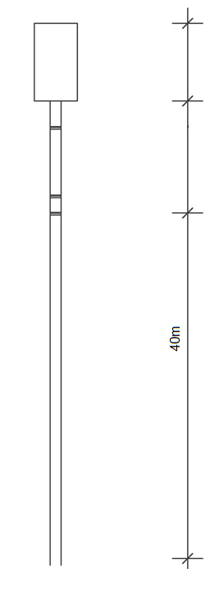

0.000

