EVENT SITE MEASUREMENT
HIGH JUMP

Rule Requirement
Runway | Length | m
 | Does this length include part of the track? | ☐ YES ☐ NO
Take-off area | It is level or the inclination complies with the rule | ☐ YES ☐ NO
Inclination | The maximum overall inclination in the last 15m of the runway and take-off area is less than 1:167 (0.6%) in the direction of the centre of the crossbar | ☐ YES ☐ NO
Notes

Runway Surface
See list: https://www.worldathletics.org/about-iaaf/documents/technical-information
Product name
Product manufacturer
Absolute thickness
World Athletics Product Certificate number

Event Site – Spot Levels
- Use the diagram to provide the required spot levels at the centre of the take-off and at 15m from the centre of each High Jump take-off.
- It is essential that reduced levels (not grades) be provided on each of the runways.
- The sign convention used by World Athletics for inclinations is that an upward inclination in the direction of running is positive.

Spot Levels – High Jump

Provide runway radial levels at the centre of the take offs (0.000m) and 15m from the centre of each High Jump take off.

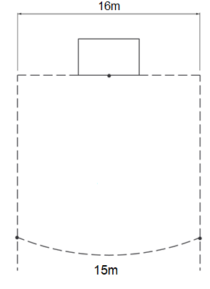

0.000

