EVENT SITE MEASUREMENT
SHOT PUT

Rule Requirement
Circle | The material complies with the rule |  | ☐ YES ☐ NO
 | The top of the rim is flush with the ground outside |  | ☐ YES ☐ NO
 | White lines (min. 0.75m) are drawn from the top of the rim |  | ☐ YES ☐ NO
 | Material of the interior surface
 | Surface is level and lower than upper edge of rim |  | ☐ YES ☐ NO
 | The metal rim is min. 6mm thick and is painted white |  | ☐ YES ☐ NO
 | D1  Depth to be provided at each end of the diameter. | Diameter | m
 |  | Depth | m
 |  | Depth | m
 | D2 | Diameter | m
 |  | Depth | m
 |  | Depth | m
 | D3 | Diameter | m
 |  | Depth | m
 |  | Depth | m
 | D4 | Diameter | m
 |  | Depth | m
 |  | Depth | m
 | Depth at centre |  | m
Landing sector | It consists of (material):
 | The maximum overall downward inclination in the putting direction does not exceed 1:1000 |  | ☐ YES ☐ NO
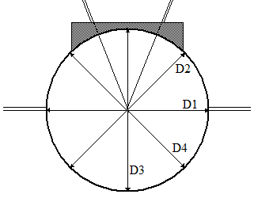

Event Site – Spot Levels – Shot Put
- Use the diagram to provide reduced levels at the circle (centre of circle = 0.000m) and for the landing area at the 10m, 15m, 20m and 25m arcs at the two sector extremities and the centreline.
- It is essential that reduced levels (not grades) be provided on each of the runways.
- The sign convention used by World Athletics for inclinations is that an upward inclination in the direction of throwing is positive. At any radius, the lowest level is compared with the throwing circle level to determine the inclination.
- The stop board must be checked before a competition.

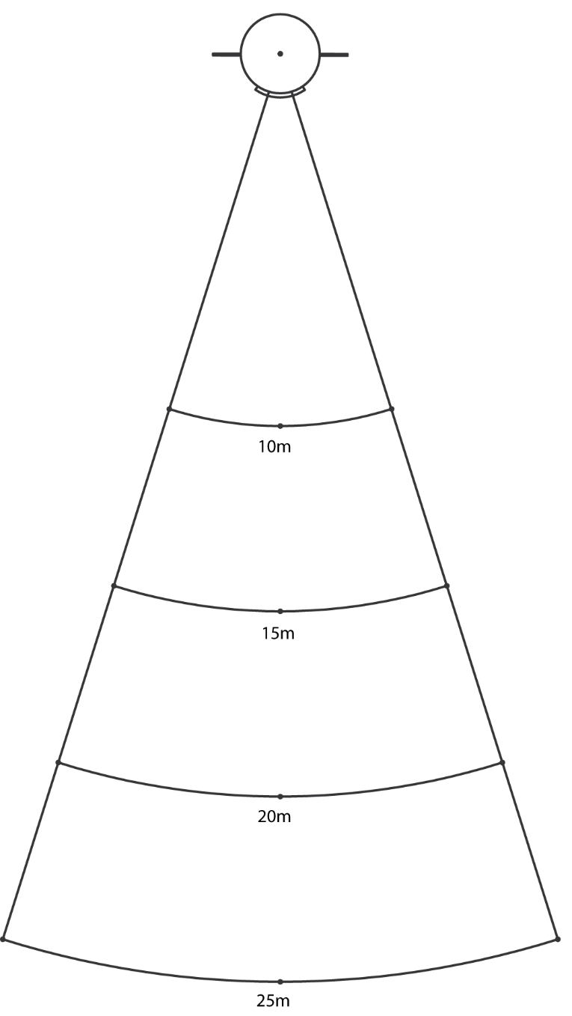
0.000

